# 

# **California State University, Los Angeles**

## MIDTERM EXAMINATION

|  |  |  |  |  |  |  |  |  |
| --- | --- | --- | --- | --- | --- | --- | --- | --- |
| Course Code | CS 4440 - 02 | | | | Time | | | 1hr 15 mn |
|  |  | | | |  | | |  |
| Course Title | Introduction to Operating Systems | | | | | | | |
|  |  |  | |  | |  |
| Academic Year | 2017/2018 | |  | Semester | | Fall |

|  |  |
| --- | --- |
| Date | Thursday, 19 October 2017 12:15 - 1:30pm |

|  |  |  |
| --- | --- | --- |
| Instructions Computers, books, notes, and phones must be closed.  Read each question carefully and completely, and answer all parts of the multipart questions.  Answers must be brief and to the point.  Phones or any other devices are not permitted.  Maximum: 30 points  Weight: 30% of total grade |  | |
|  |  | |
| Instructor | Dr. Thomas | |
|  |  | |
| Name of Student | Robert Martinez |  |
|  |  | |

1. (2 points) Figure shows the storage-device hierarchy. In alphabetic order the storage systems are cache, hard disk, magnetic tapes, main memory, optical disk, registers, and solid-state disk (Dynamic RAM, flash, etc.). Organize the storage systems according to speed and cost. Which is the fastest? Which is the costliest? Which are volatile? Which is the most common secondary storage device?

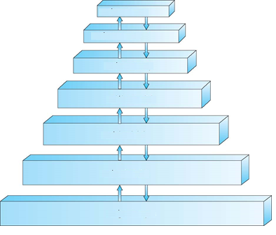

1. Registers
2. Cache
3. CPU
4. Memory
5. SSD
6. HDD
7. Optical Disk

Registers is the fastest out of all the storage devices.

Optical disk is the costliest out of all storage devices.

Memory is volatile.

HDD are commonly the secondary storage device.

1. (1 point) How many times does the following program print hello?

#include <stdio.h>

#include <unistd.h>

main()

{

int i;

for (i=0; i<3; i++)

fork();

printf("hello\n");

}

Answer: This prints hello 6 times

1. (1 point) In the dual mode of operation, in which mode does the hardware allow privileged instructions to be executed?

Answer: Kernel Mode

1. (1 point) What is the potential danger in running the following code?

while(1) fork();

Answer: The potential danger could be that there will be no more children and therefore throw an error.

1. (1 point) What is the software that acts as an intermediary between the user of system and the computer hardware? Give an example of an open-source software for this use.

Answer: The operating system acts as the intermediary between the user and the computer hardware. Linux, would be considered a open source software.

1. (2 points) Draw the process state diagram.

Answer: On paper

1. (1 point) What is a system call? Give an example of a system call.

Answer: A system call is when processor is called to execute a task. For example, if the processor is an idle (or waiting), then a user executes a program, the system call will then choose to execute the program that the user clicked on.

1. (1 point) What is the degree of multiprogramming?

Answer: The degree of multiprogramming is when you have a certain amount of programs that still need to be ran.

1. (2 points) Figure shows a process in memory. What do text, heap, and stack contain?

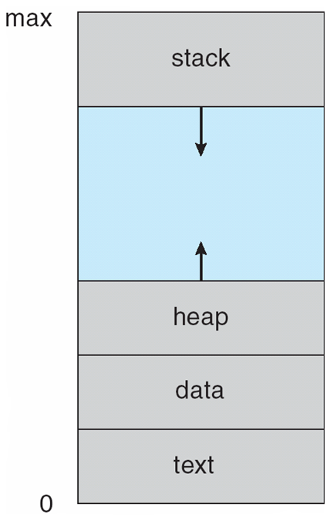

Stack contains temporary data.

The heap contain information that is gathered during runtime.

The text contains output from the data itself.

1. (1 point) What is the **pid** of **init** process?

The PID of the init process is the

1. (1 point) What is a process? A file called foo.java is stored in your computer. How can it become a ‘process’?

Answer: A processes is a program that is being placed into memory and being executed.

Answer: Foo.java is placed onto the memory and is then executed.

1. (2 points) Illustrate by figures showing that it is possible to have concurrency without parallelism in programming.
2. (2 points) When using semaphores, a process invokes the wait() operation before accessing its critical section, followed by the signal() operation upon completion of its critical section. Consider reversing the order of these two operations—first calling signal(), then calling wait(). What would be a possible outcome of this?

You cannot perform this operation when reversing, because it will be in a continuous loop that will never stop and eventually crash the program.

1. (2 points) Imagine that a host with IP address 150.55.66.77 wishes to download a file from the web server at IP address 202.28.15.123. A web server listens to port 80. Select a valid socket pair for a connection between this pair of hosts.

In this case, they would be connected with a TCP connection, because it is reliable and great for downloading. Since the file cannot be interrupted or stopped, so TCP would be the socket connected to.

1. (2 points) Write the code to implement the simple semaphore wait() and signal() operations on global variable S.

wait (S) {

while (s <= 0)

;

s--;

}

signal (S) {

S++;

}

1. (2 points) Explain the circumstances when the line of code marked printf("I am child") in figure is reached.

#include <sys/types.h>

#include <stdio.h>

#include <unistd.h>

int main()

{

pid t pid;

/* fork a child process */

pid = fork();

if (pid < 0) { /* error occurred */

fprintf(stderr, "Fork Failed");

return 1;

}

else if (pid == 0) { /* child process */

execlp("/bin/ls","ls",NULL);

printf("I am Child");

}

else { /* parent process */

/* parent will wait for the child to complete */

wait(NULL);

printf("Child Complete");

}

return 0;

}

Answer: Under those circumstances, the child is continuing to execute with forking. If that is the case, it will continue executing even after the parent is finished.

1. (3 points) Race conditions are possible in many computer systems. Consider a banking system that maintains an account balance with two functions: deposit(amount) and withdraw(amount). These two functions are passed the amount that is to be deposited or withdrawn from the bank account balance. Assume that a husband and wife share a bank account. The balance in the account is $ 300.00. Concurrently, the husband calls withdraw(50) and the wife calls deposit(100). Describe how a race condition is possible and what might be done to prevent the race condition from occurring.

The race condition is possible, because it allows two or more ways to make changes. In this case, both husband and wife make a change to the bank account. What might prevent from occurring is if husbands and wife both withdraw more than what the bank holds.

1. (2 points) In the dining-philosophers problem, what corresponds to the critical section? What are the resources shared? What is the remainder section? Can two neighbors eat simultaneously?

The critical section is are the people eating at the dinner table.

The recources shared are the chopsticks needed to eat.

The remainder section is the amount of people who are not eating.

2 neighbors cannot eat simultaneously.

1. (1 point) What is POSIX?

POSIX stands for portable operating system interface. POSIX Is typically implemented on software such as Linux, Unix, and Mac. It also has it’s own API.

1. (bonus 2 point) Unlike other computer languages, Java has its own threads library called Java threads. Why?

It has it’s own java threads, because it has the Java Virtual Machine. The java virtual machine allows java to be ran on everything, which includes on all operating systems.

1. (1 point) When OpenMP encounters the #pragma omp parallel directive, what will it do?

This will count and increment the values one by one:

Count += value

1. (bonus 2 points) The content of the text file numbers.txt is as follows:

1 6 1 8 3 10 8

What is the content of numbers.txt after the following command?

cat numbers.txt | sort | unique > numbers.txt

The content of the numbers will include: 1 3 6 8 10